WEBD 1000 HTML TabLE STRUCTURE

**Website Development**

# Instructions

**You will complete the following steps in class and post the file(s) that you are asked to produce to the Brightspace dropbox for today’s in-class activity. If you need help with any step, ask the instructor.**

1. In the BrightSpace dropbox for today’s activity, you have been provided with a ZIP file containing some file resources for a web page:
   1. An HTML page called *conference.html*
   2. CSS files called *styles.css*.
2. Copy the site to an Exercise 14 folder in your preferred folder location for this class.
3. Open the site files in NotePad++ (or the editor of your choice):
   1. Preview the *conference.html* file in a browser. Your page should look like the BEFORE image on the following page.
4. **See the AFTER picture on the next page(s) for an idea of what the Webpage should ultimately look like.**
5. Modify the conference.html page:
   1. add the HTML table for the conference schedule
6. Modify the styles.css file:
   1. apply the additional CSS styling so that the table looks like the AFTER image
7. Once the above Steps are completed, validate the ***conference.html*** file using the W3C **HTML** validation website and the ***styles.css*** file using the W3C **CSS** validation website. Take screenshot(s) showing successful validation.
8. Post a ZIP file containing both **the whole website** plus **screenshot(s) of successful validation** to the Brightspace Dropbox for the fourteenth in-class exercise in order to obtain credit for completing it.
9. That’s it.

# Highly Recommended

**There is no need to submit the results of this part of the activity and it will not be graded. However, it will be excellent practice for the upcoming assignment. If you need help with any step, ask the instructor.**

1. Complete the Tutorial 6 – Session 1 practice steps from the Textbook. The practice tutorial steps are in light brown or beige boxes within the chapters of the textbook. In this case the tutorial steps begin on page **HTML455** (Section 6-2a) and conclude on page **HTML473** (Section 6-5) for this Session.
2. Once the above Step is completed, validate both your *dlr_evenings.html* and *dlr_tables.css* files using the appropriate W3C validation websites for each.

# Before:

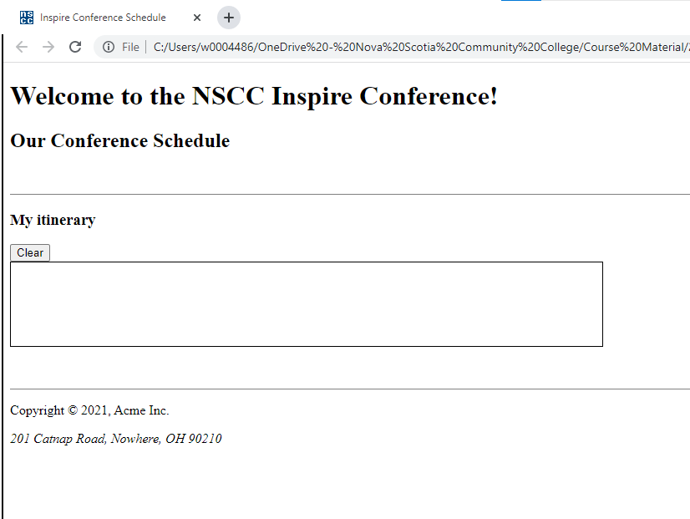

# After:

